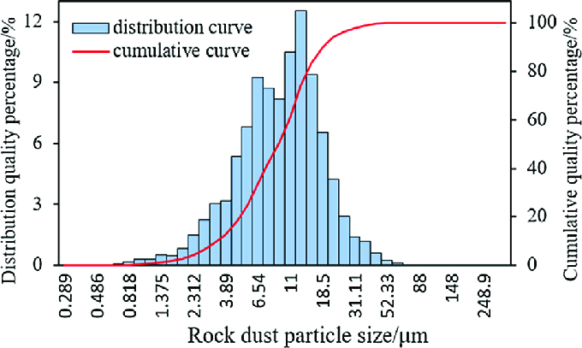

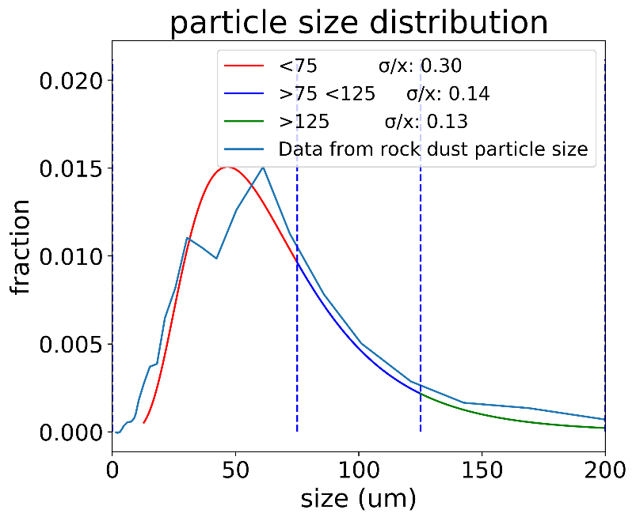

*Ref*:[*https://www.researchgate.net/publication/324913292_Influence_of_pleat_geometry_on_the_filtration_and_cleaning_characteristics_of_filter_media*](https://www.researchgate.net/publication/324913292_Influence_of_pleat_geometry_on_the_filtration_and_cleaning_characteristics_of_filter_media)

The particle distribution is assumed to be general normal distribution.

Parameters associated with this distribution:

Mean (mu), standard deviation (sigmas), kurtosis (beta).

Assumed value for the constants:

beta = 0.5

sigma = 60

mu = 0

All these parameters have large impact on the fill factor of the different particle size.

The $σ/x$ is calculated through the truncated distribution.

The sieve is assumed to be perfect in terms that it can separate the range of particle size perfectly.

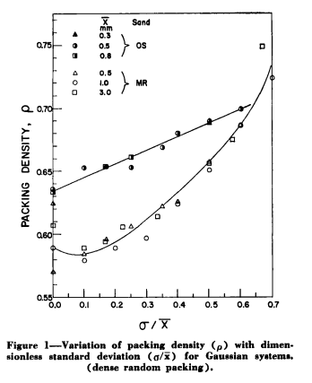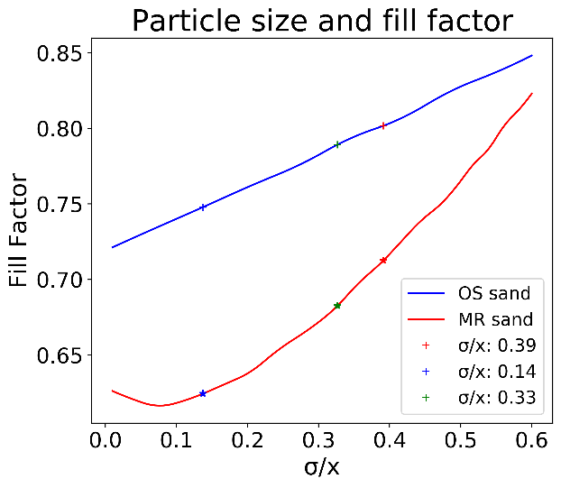

The $σ/x$ is then substituted into the graph on the left to calculated the filling factor range.

|  |  |  |  |  |
| --- | --- | --- | --- | --- |
|  | σ/x | lower | upper | fill factor |
| <75 | 0.3027 | 0.6727 | 0.7831 | 0.7279±0.0552 |
| >75 <125 | 0.1448 | 0.6259 | 0.7494 | 0.6876±0.0618 |
| >125 | 0.1286 | 0.6227 | 0.7460 | 0.6844±0.0616 |

The range of estimation error is shown above:

The fill factor has a lower and upper bound depend on the whether particle geometry is more closely resembles OS or MR sand.

However, in both cases, the fill factor increases. Which means the EM absorption increase when the particle size is smaller.